**Module 3: Spring Core and Maven**

**Exercise 1: Configuring a Basic Spring Application**

package com.library.repository;

public class BookRepository {

public void displayBooks() {

System.out.println("Displaying list of books from the repository...");

}

}

package com.library.Service;

import com.library.repository.BookRepository;

public class BookService {

private BookRepository bookRepository;

// Setter for Dependency Injection

public void setBookRepository(BookRepository bookRepository) {

this.bookRepository = bookRepository;

}

public void showBooks() {

System.out.println("Inside BookService...");

bookRepository.displayBooks();

}

}

package com.library.Main;

import org.springframework.context.ApplicationContext;

import org.springframework.context.support.ClassPathXmlApplicationContext;

import com.library.Service.BookService;

public class MainApp {

public static void main(String[] args) {

ApplicationContext context = new ClassPathXmlApplicationContext("applicationContext.xml");

BookService bookService = (BookService) context.getBean("bookService");

bookService.showBooks();

((ClassPathXmlApplicationContext) context).close();

}

}

**Output:**

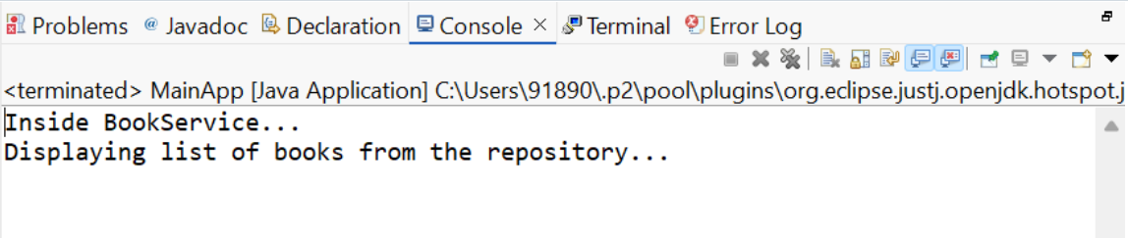

**Exercise 2: Implementing Dependency Injection**

**Application.xml**

<?xml version="1.0" encoding="UTF-8"?>

<beans xmlns="http://www.springframework.org/schema/beans"

xmlns:xsi="http://www.w3.org/2001/XMLSchema-instance"

xsi:schemaLocation="http://www.springframework.org/schema/beans

https://www.springframework.org/schema/beans/spring-beans.xsd">

<!-- BookRepository Bean -->

<bean id="bookRepository" class="com.library.repository.BookRepository"/>

<!-- BookService Bean with Dependency Injection -->

<bean id="bookService" class="com.library.Service.BookService">

<property name="bookRepository" ref="bookRepository"/>

</bean>

</beans>

package com.library.Service;

import com.library.repository.BookRepository;

public class BookService {

private BookRepository bookRepository;

// Setter for Dependency Injection

public void setBookRepository(BookRepository bookRepository) {

this.bookRepository = bookRepository;

}

public void showBooks() {

System.out.println("Inside BookService...");

bookRepository.displayBooks();

}

}

**Main.java**

package com.library.Main;

import org.springframework.context.ApplicationContext;

import org.springframework.context.support.ClassPathXmlApplicationContext;

import com.library.Service.BookService;

public class MainApp {

public static void main(String[] args) {

ApplicationContext context = new ClassPathXmlApplicationContext("applicationContext.xml");

BookService bookService = (BookService) context.getBean("bookService");

bookService.showBooks();

((ClassPathXmlApplicationContext) context).close();

}

}

**Output:**

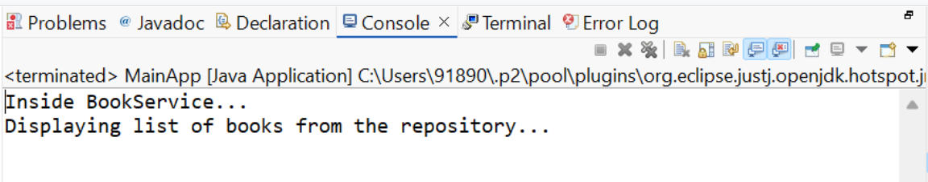

**Exercise 4: Creating and Configuring a Maven Project**

<project xmlns="http://maven.apache.org/POM/4.0.0"

xmlns:xsi="http://www.w3.org/2001/XMLSchema-instance"

xsi:schemaLocation="http://maven.apache.org/POM/4.0.0

http://maven.apache.org/xsd/maven-4.0.0.xsd">

<modelVersion>4.0.0</modelVersion>

<groupId>com.library</groupId>

<artifactId>LibraryManagement</artifactId>

<version>0.0.1-SNAPSHOT</version>

<packaging>jar</packaging>

<dependencies>

<!-- Spring Core / Context -->

<dependency>

<groupId>org.springframework</groupId>

<artifactId>spring-context</artifactId>

<version>5.3.34</version>

</dependency>

<!-- Spring AOP -->

<dependency>

<groupId>org.springframework</groupId>

<artifactId>spring-aop</artifactId>

<version>5.3.34</version>

</dependency>

<!-- Spring Web MVC -->

<dependency>

<groupId>org.springframework</groupId>

<artifactId>spring-webmvc</artifactId>

<version>5.3.34</version>

</dependency>

</dependencies>

<build>

<plugins>

<!-- Set Java version to 1.8 -->

<plugin>

<groupId>org.apache.maven.plugins</groupId>

<artifactId>maven-compiler-plugin</artifactId>

<version>3.8.1</version>

<configuration>

<source>1.8</source>

<target>1.8</target>

</configuration>

</plugin>

</plugins>

</build>

</project>

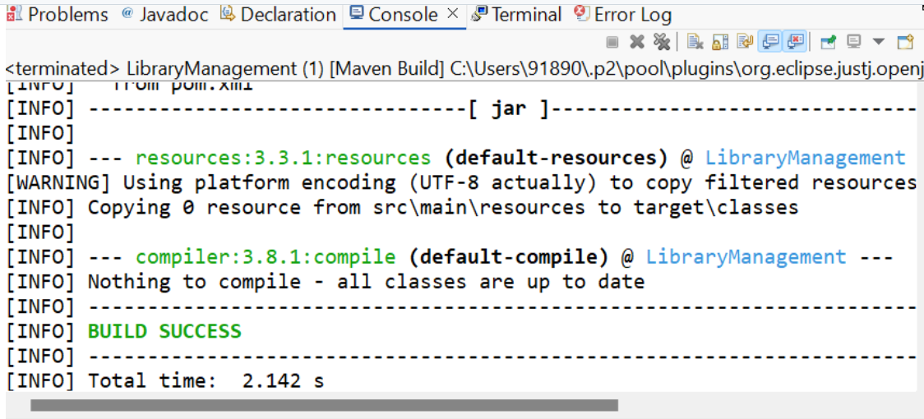**Output**